# Lab 05 - Implement Intersite Connectivity

Made by Valeriy Manuilyk <3

## Task 1: Create a core services virtual machine and virtual network

1.Sign in to the ****Azure portal**** - https://portal.azure.com.

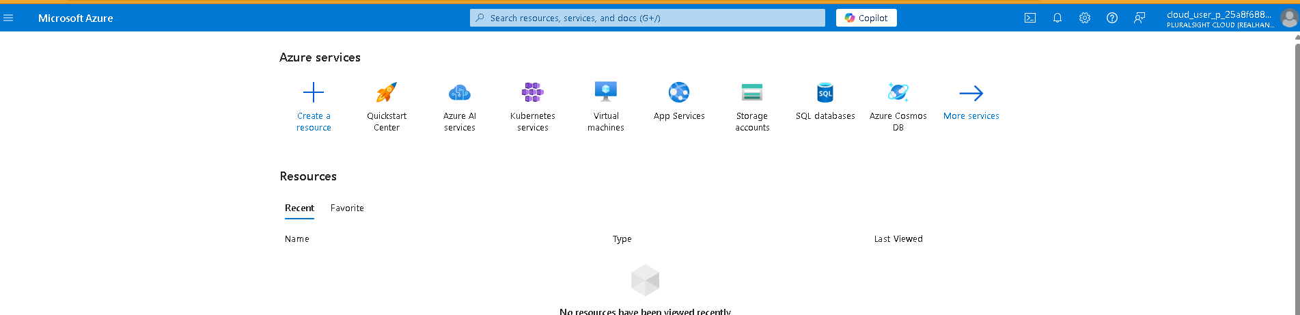

2.Search for and select Virtual Machines.

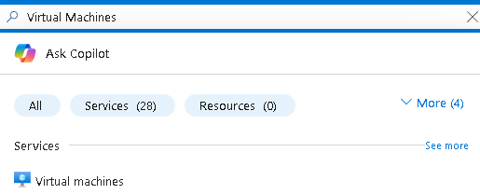

3.From the virtual machines page, select ****Create**** then select ****Azure Virtual Machine****.

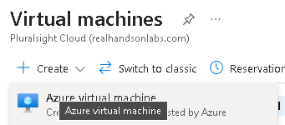

4.On the Basics tab, use the following information to complete the form, and then select ****Next: Disks >****. For any setting not specified, leave the default value.

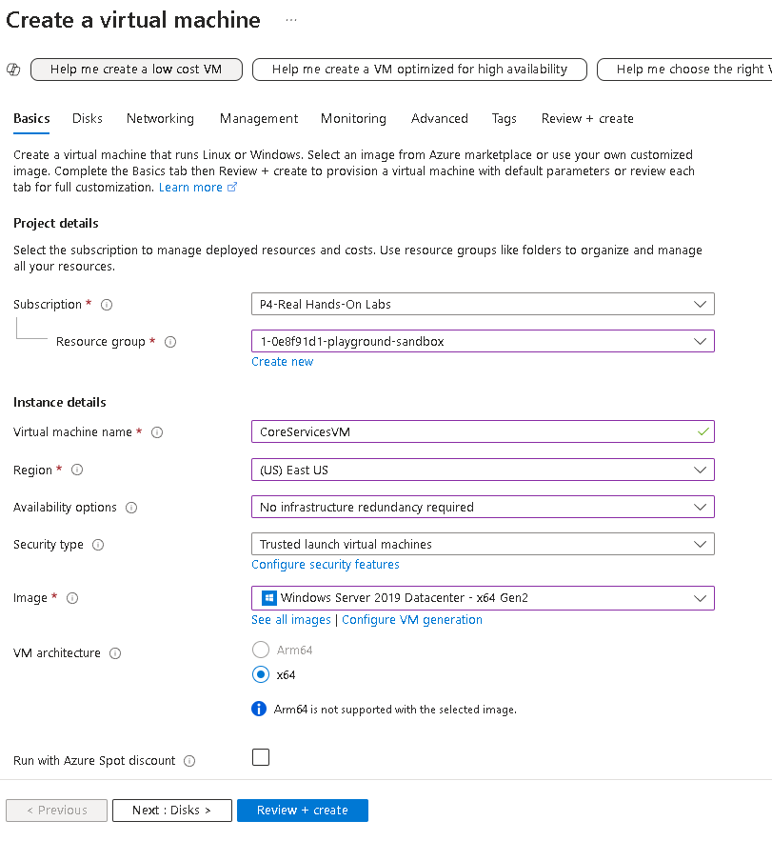

5.On the ****Disks**** tab take the defaults and then select ****Next: Networking >****.

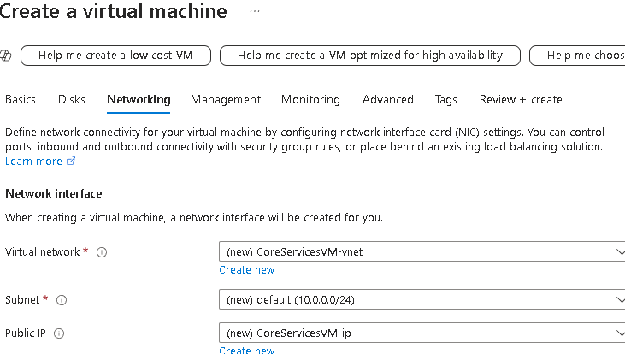

6.On the ****Networking**** tab, for Virtual network, select ****Create new****.

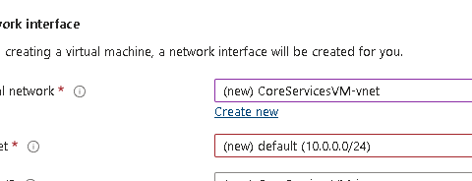

7.Use the following information to configure the virtual network, and then select ****Ok****. If necessary, remove or replace the existing information.

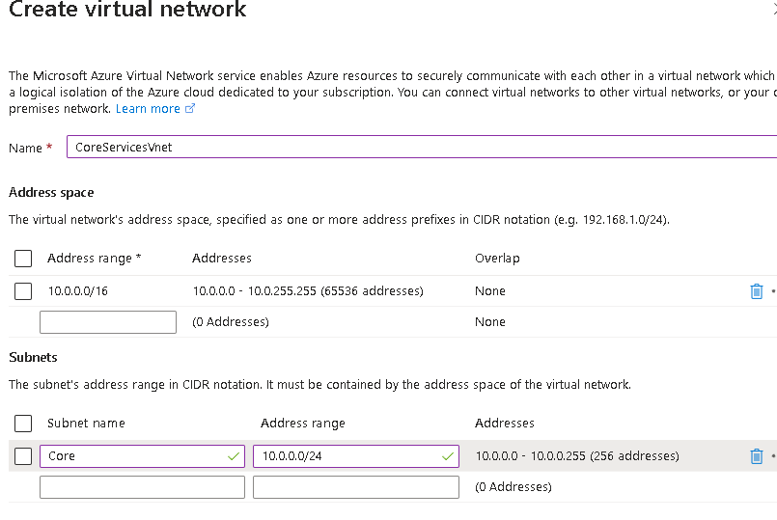

8.Select the ****Monitoring**** tab. For Boot Diagnostics, select ****Disable****.

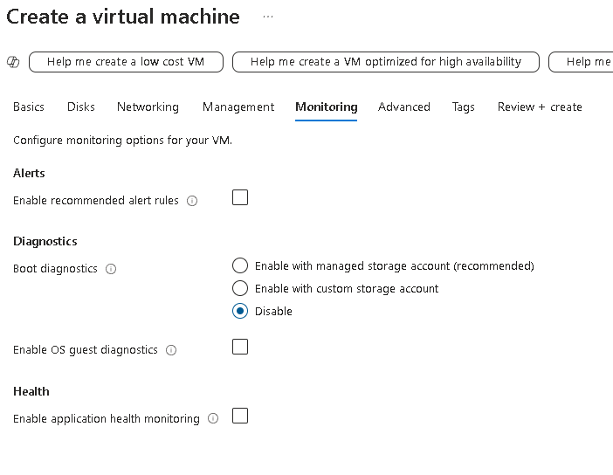

9.Select ****Review + Create****, and then select ****Create****.

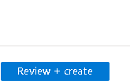

10.You do not need to wait for the resources to be created. Continue on to the next task.

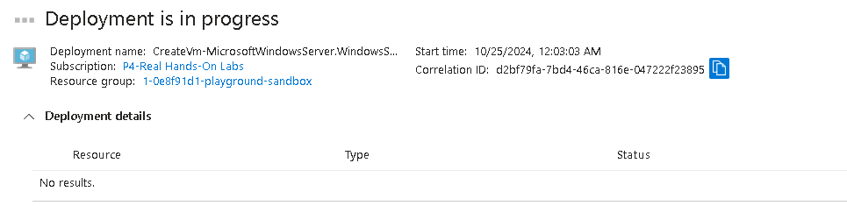

## Task 2: Create a virtual machine in a different virtual network

1.From the Azure portal, search for and navigate to ****Virtual Machines****.

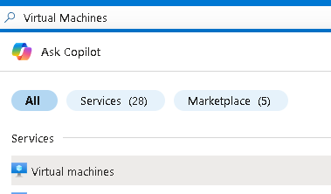

2.From the virtual machines page, select ****Create**** then select ****Azure Virtual Machine****.

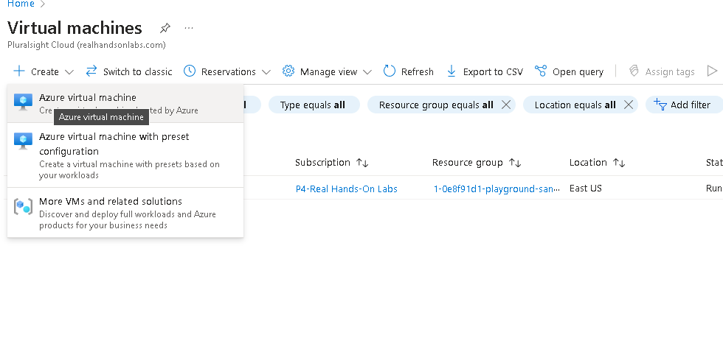

3.On the Basics tab, use the following information to complete the form, and then select ****Next: Disks >****. For any setting not specified, leave the default value.

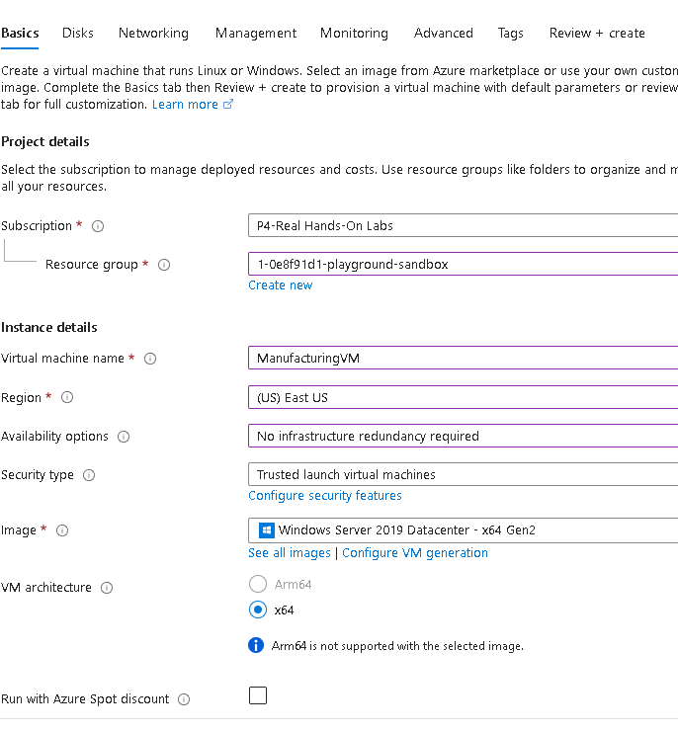

4.On the ****Disks**** tab take the defaults and then select ****Next: Networking >****.

5.On the Networking tab, for Virtual network, select ****Create new****.

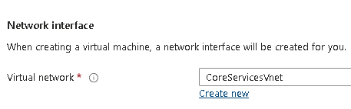

6.Use the following information to configure the virtual network, and then select ****Ok****. If necessary, remove or replace the existing address range.

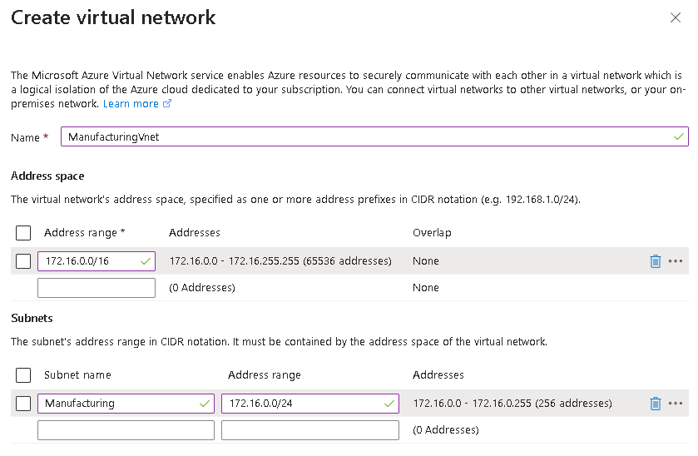

7.Select the ****Monitoring**** tab. For Boot Diagnostics, select ****Disable****.

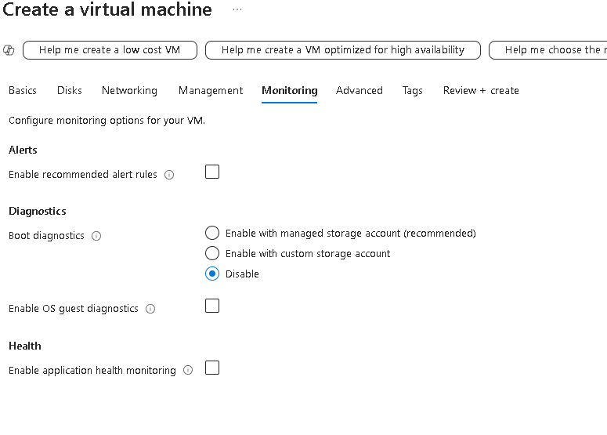

8.Select ****Review + Create****, and then select ****Create****.

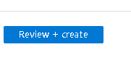

## Task 3: Use Network Watcher to test the connection between virtual machines

1.From the Azure portal, search for and select Network Watcher

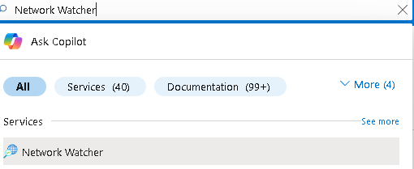

2.From Network Watcher, in the Network diagnostic tools menu, select ****Connection troubleshoot****.

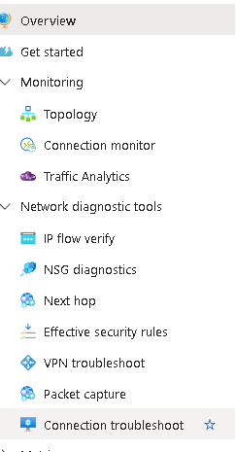

3.Use the following information to complete the fields on the ****Connection troubleshoot**** page.

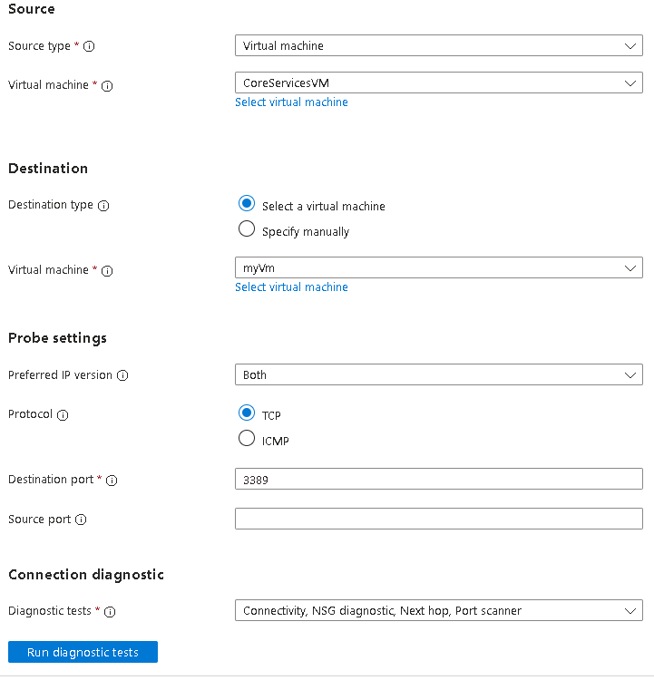

4.Select ****Run diagnostic tests****.

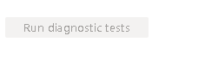

## Task 4: Configure virtual network peerings between virtual networks

1.In the Azure portal, select the CoreServicesVnet virtual network.

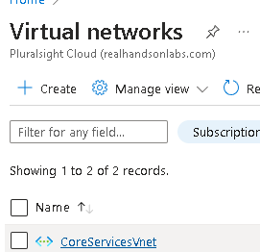

2.In CoreServicesVnet, under ****Settings****, select ****Peerings****.

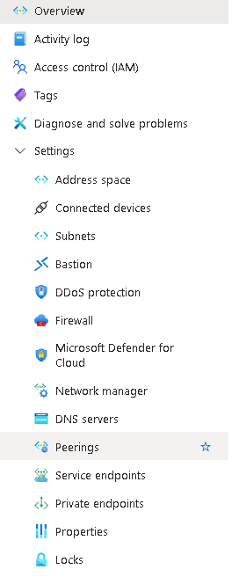

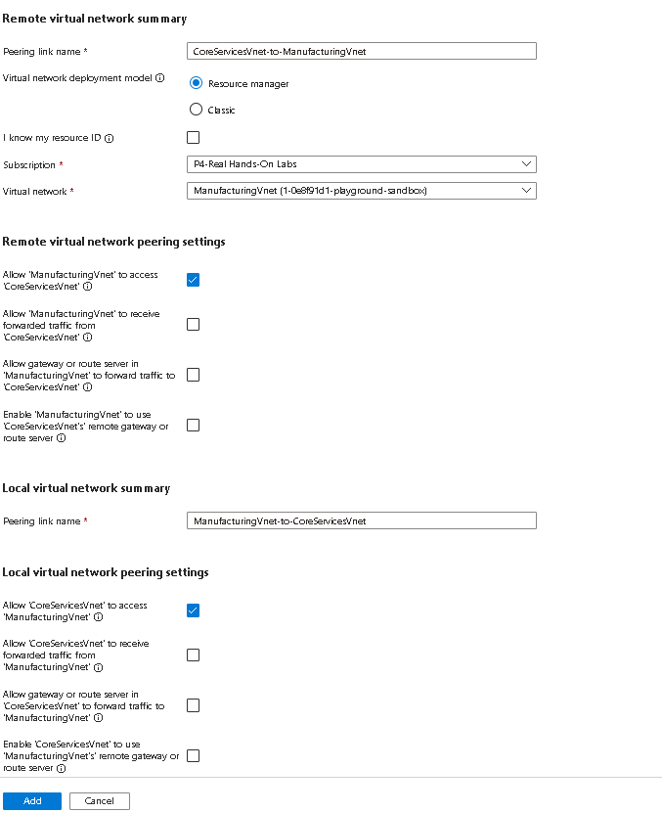

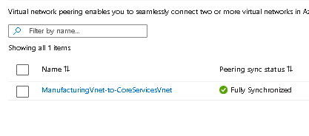

## Task 5: Use Azure PowerShell to test the connection between virtual machines

### Verify the private IP address of the CoreServicesVM

1.From the Azure portal, search for and select the CoreServicesVM virtual machine.

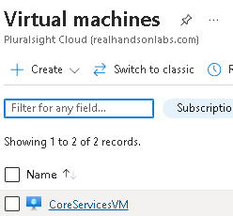

2.On the ****Overview**** blade, in the ****Networking**** section, record the ****Private IP address**** of the machine. You need this information to test the connection.

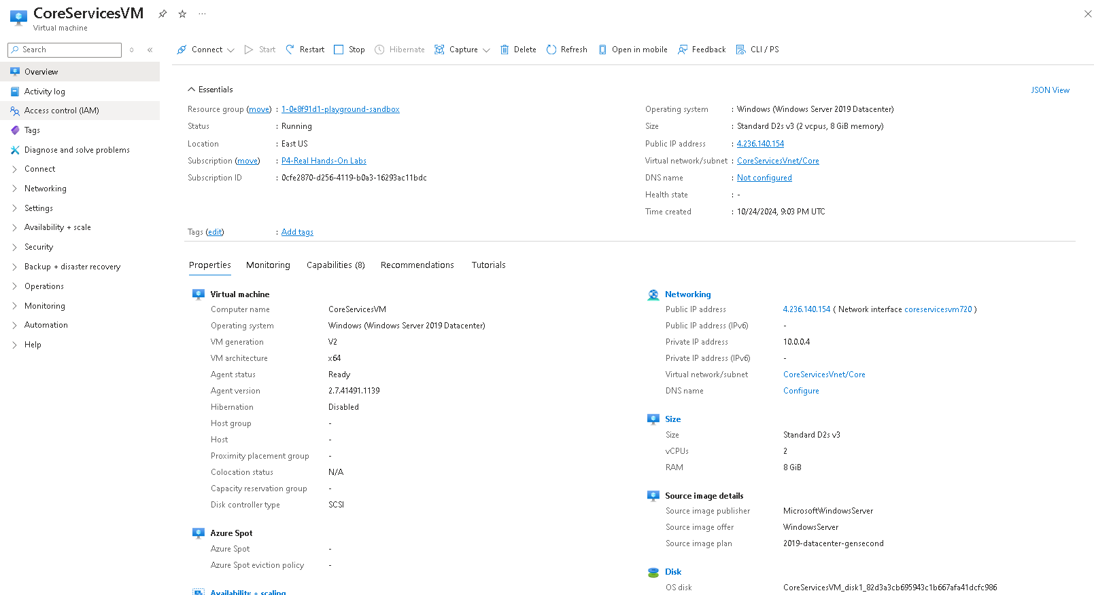

## Task 6: Create a custom route

1.Search for select the CoreServicesVnet.

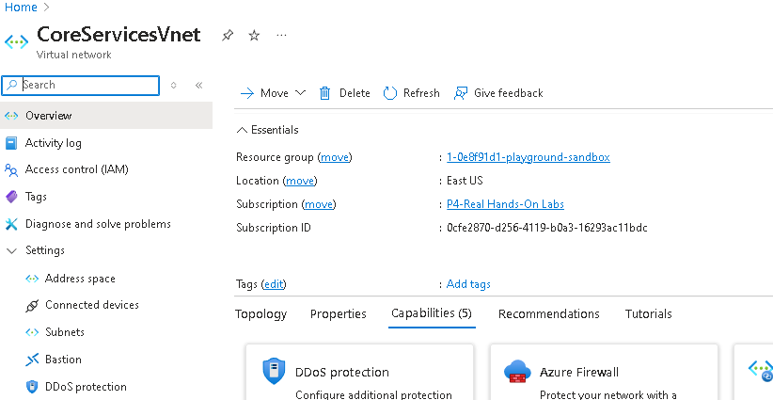

2.Select ****Subnets**** and then ****+ Create****. Be sure to ****Save**** your changes.

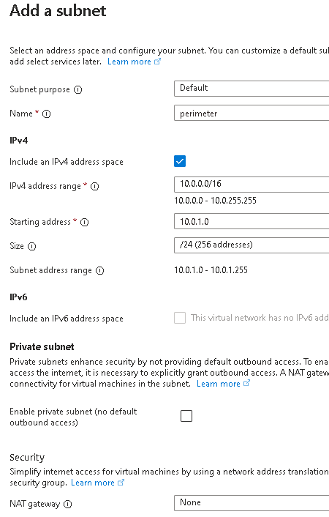

3.In the Azure portal, search for and select Route tables, and then select ****Create****.

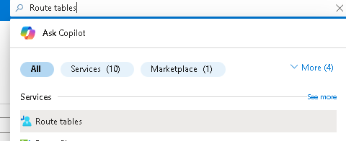

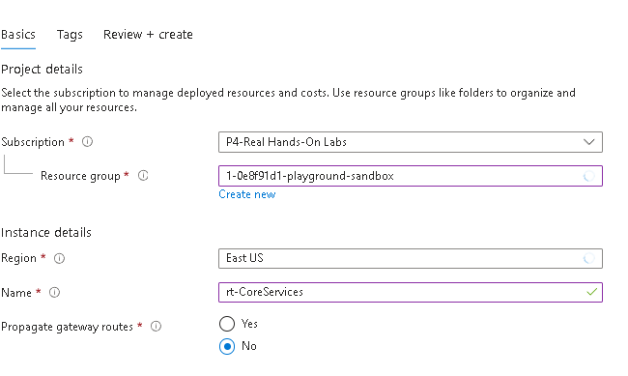

4.After the route table deploys, select ****Go to resource****.

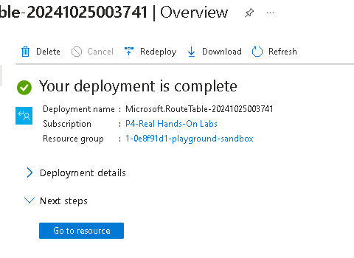

5.Select ****Routes**** and then ****+ Add****. Create a route from the future NVA to the CoreServices virtual network.

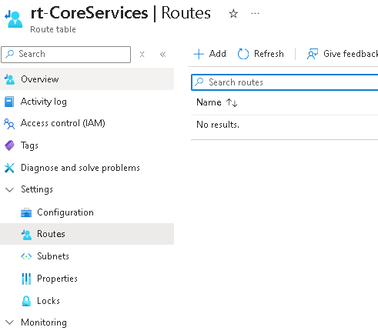

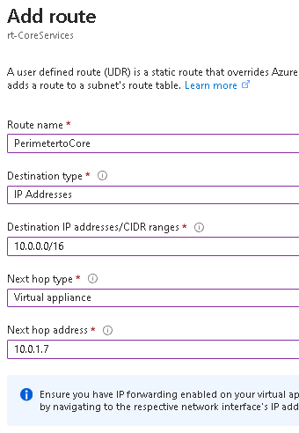

6.Select ****+ Add**** when the route is completed. The last thing to do is associate the route with the subnet.

7.Select ****Subnets**** and then ****Associate****. Complete the configuration.

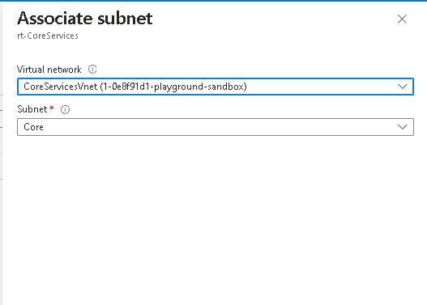

**Conclusionss**

By default, resources in different virtual networks cannot communicate.

Virtual network peering enables you to seamlessly connect two or more virtual networks in Azure.

Peered virtual networks appear as one for connectivity purposes.

The traffic between virtual machines in peered virtual networks uses the Microsoft backbone infrastructure.

System defined routes are automatically created for each subnet in a virtual network. User-defined routes override or add to the default system routes.

* Azure Network Watcher provides a suite of tools to monitor, diagnose, and view metrics and logs for Azure IaaS resources.